
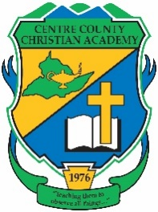


School: Centre County Christian
Team Colors: Green & Gold
Wins _____ Losses ______ Ties _____
Opponent: __________________________
Head Coach: Ken Gore
Assistant Coach: Ryan Smith

Date: ______________________

Number | Name | Year | Position | Homeschool
9 | Max Fedorov | 12 |  | X
19 | Evan Gore | 12
10 | Stephan Kondratyev | 12
14 | Elliot Pimentel | 12
28 | Ben Rossman | 12
32 | Grant Smith | 12 | Keeper
33 | Isaiah Hoffmann | 11 |  | X
22 | Jacob Kolosov | 10 |  | X
24 | Josiah Pimentel | 10
42 | Owen Smith | 10
37 | Trent White | 10
8 | Daniel Berezhnoy | 9
30 | Eli Caton | 9 |  | X
23 | Jason Kerstetter | 9
38 | Brock Shipe | 8 |  | X
13 | Avenir Berezhnoy | 7
 | Not ACAA eligible
16 | Oren Shaffer | 12 |  | XX
54 | Micah Boonstra | 6
31 | Jake Rossman | 6

